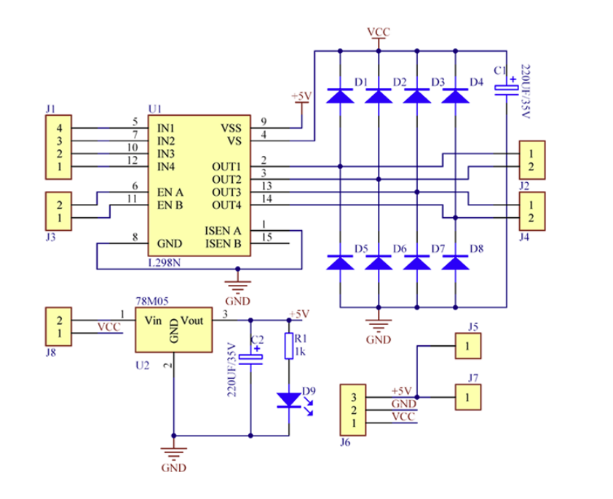

### **J1 (IN1, IN2, IN3, IN4 - Direction Control):**

* **J1** is connected to the directional control pins of the L298N motor driver (**IN1, IN2, IN3, IN4**). Each pair of inputs (IN1/IN2 and IN3/IN4) controls the **direction** of one motor.
  + If you set **IN1** high and **IN2** low, the motor connected to **OUT1/OUT2** will spin in one direction.
  + If you reverse this (IN1 low and IN2 high), the motor will spin in the opposite directions

### **J3 (Enable A/B - Speed Control via PWM):**

* **J3** takes the PWM signals (or high/low logic) to control the **enable** status of the motors. By sending a PWM signal to the **EN A** and **EN B** pins, you are effectively controlling the **speed** of the motors. PWM modulation allows you to vary the voltage over time, which makes the motor spin faster or slower based on the duty cycle.

**J3**: Controls **motor speed** via PWM signals on the **Enable pins (EN A/EN B)**.

**J1**: Controls **motor direction** via high/low logic on the **IN1, IN2, IN3, IN4 pins**.

**ISEN A and ISEN B:**

* **ISEN A** corresponds to **motor outputs OUT1 and OUT2** (for the first motor or motor A).
* **ISEN B** corresponds to **motor outputs OUT3 and OUT4** (for the second motor or motor B).

The **ISEN pins** are used to measure the current flowing through the motors connected to the driver. By adding a **current-sensing resistor** between these pins and ground, you can measure the voltage drop across the resistor, which is proportional to the motor current. This allows you to monitor the amount of current each motor is drawing.

**SS (Logic Supply and VS (Motor Supply):**

If you have a **6V battery**:

1. **VS (Motor Voltage)**: Connect the **6V battery** directly to the **VS** pin. The motors can be powered directly by the 6V supply.
2. **VSS (Logic Voltage)**: Use a **voltage regulator** (like the **78M05**) to step down the **6V to 5V**. The output of the regulator will provide the necessary 5V for the **VSS** pin.

### **OUT1, OUT2, OUT3, OUT4:**

These pins represent the outputs to the motors.

* **OUT1 and OUT2** can be driven either **high or low**, depending on the input signals (IN1 and IN2).
* By controlling the states of these pins, the motor can spin forward, reverse, or stop:
  + **OUT1 high and OUT2 low**: The motor spins in one direction.
  + **OUT1 low and OUT2 high**: The motor spins in the opposite direction.
  + **Both OUT1 and OUT2 low**: The motor stops (brakes).
  + **Both OUT1 and OUT2 high**: The motor coasts (free runs).
* **OUT3 and OUT4** can also be driven high or low to control the second motor's direction and speed.
* The behavior is the same as with Motor A:
  + **OUT3 high and OUT4 low**: The motor spins in one direction.
  + **OUT3 low and OUT4 high**: The motor spins in the opposite direction.
  + **Both OUT3 and OUT4 low**: The motor stops (brakes).
  + **Both OUT3 and OUT4 high**: The motor coasts (free runs).

**Motor A (First N20 Motor)**:

* **OUT1** and **OUT2** should be connected to the terminals of your **first N20 gear motor**. One motor terminal to **OUT1** and the other to **OUT2**.

**Motor B (Second N20 Motor)**:

* **OUT3** and **OUT4** should be connected to the terminals of your **second N20 gear motor** (if you are using a second motor). One motor terminal to **OUT3** and the other to **OUT4**.

**OUT1**, **OUT2**, **OUT3**, and **OUT4** are **motor output pins** and should be **directly connected to your N20 motors**.

### **FLYBACK DIODES D1 to D4:**

* **D1 and D2**: These diodes are connected to the outputs **OUT1** and **OUT2** (for Motor A). When the current in the motor connected to OUT1 and OUT2 is suddenly interrupted or reversed, the diodes allow the voltage spike to be safely diverted.
  + **D1** is placed across **OUT1** and the motor's power supply (VS).
  + **D2** is placed across **OUT2** and the motor's power supply (VS).
* **D3 and D4**: Similarly, these diodes are connected to the outputs **OUT3** and **OUT4** (for Motor B). When the current in the second motor is interrupted, the diodes allow the voltage spike to be safely dissipated.
  + **D3** is placed across **OUT3** and the motor's power supply (VS).
  + **D4** is placed across **OUT4** and the motor's power supply (VS).

The diodes **D1 to D4** in your L298N motor driver are typically **Schottky diodes** that can handle the reverse voltage and current spikes generated by the motors.

​​**VCC (Logic Supply):**

* **VCC** typically refers to the **logic voltage** in a circuit. This voltage powers the logic circuitry of the L298N, which interprets the control signals (IN1, IN2, ENA, etc.) and controls the motors.
* The L298N motor driver’s logic circuit is designed to operate at **5V** (VSS), so **VCC** should ideally be **5V** to match the logic requirements of the L298N.
  + Even though you have a 6V battery, **VCC (VSS)** should still be regulated down to **5V** using a voltage regulator, such as the **78M05** voltage regulator in your circuit.